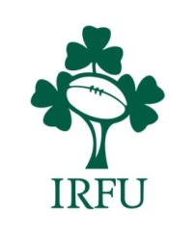
PLEASE SUBMIT THIS EXPRESSION OF INTEREST TO YOUR LISTED PROVINCIAL CONTACT
Return emails with subject: “Performance Coach Award” before FRIDAY 29th May 2020

(Please DO NOT submit any payment until your place and the course details are confirmed by official invitation)

IRFU Performance Coach Course 2020
From 2019 onwards the IRFU Stage 4 Head and Assistant Coaching Course has been replaced by the IRFU Performance Coaching Award.

A confirmed date will be communicated upon acceptance to the course and will be subject to government guidelines at the time - it is initially anticipated this may be through July/August 2020.
Depending on the course format, you may have the option of undertaking some elective modules. Please indicate from the options below (1-3) which module you would prefer to attend. These modules will run concurrently meaning only one can be selected per choice.
Place an X beside the topic you wish to attend for each practical choice below
Practical choice 1 | Practical choice 2 | Practical choice 3
Scrum | Lineout | Kick Restarts.
OR | OR | OR
Backline Attack/Defence | Counter Attack | Kicking

Name: | Coaching Experience | Role?  (Head / Assistant)
Date of Birth: | Team 2019-2020:
Home Address: | Team 2018-2019:
Email address: | Team 2017-2018:
Mobile Phone: | Team 2016-2017:
Your Details - please print clearly

Return email address:
Ulster - gavin.hogg@ulsterrugby.com
Munster - education@munsterrugby.ie
Connacht - eamonn.molloy@connachtrugby.ie
Leinster - Declan.obrien@leinsterrugby.ie

